Discussion Tx Government Due November 18, 2020 9:00 p.m. Central Time

This is the assignment for Chapter 3.

This module covers interest groups. Organized interests are considered to be an important linkage institution with a lot of influence over the policy process. Democratic theory requires open processes that allow all citizens to participate. Assuming that, we need to assess the extent to which these processes are open to everyone. Also, we want to determine if we have an equal opportunity to influence the political system and the public policies it produces.

Interest groups are composed of like-minded individuals trying to influence public policy in their favor. However, such groups are not the only actors in the policy making process. Below, Figure 1 depicts the political system as converting inputs (i.e., supports and demands) into outputs. The system is the black box at the center with all of the most important political actors listed. Figure 2 depicts the political system in terms process functions--that is, processes that must be completed in order to make public policy. Notice how the outputs authoritatively allocate resources in the domestic environment and provide inputs to the national and international environments. You should understand that interest groups seek to influence the policy process through as many process and system functions as they are able. The extent to which they successfully influence (even control sometimes) these functions increases the probability that they will achieve the outputs they desire. This is easier said than done though, considering the resources and organization required to achieve that level of influence. Some interest groups in Texas are better suited to influence the black box than others.
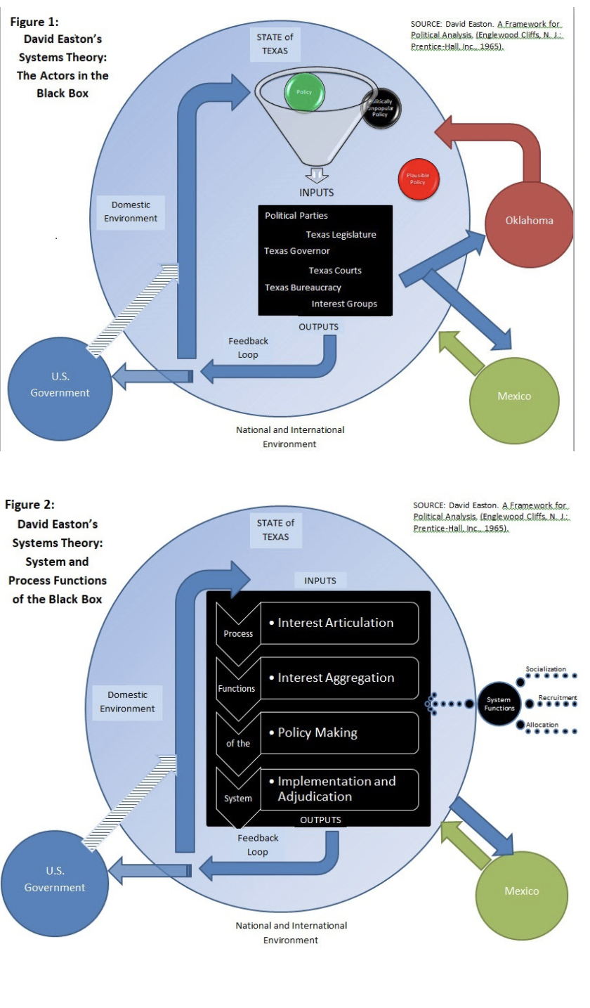

Here are 2 videos that will help you assimilate the information from Chapter 3 and help place it into context.

This video https://youtu.be/bOvBA7oIIgc provides a good review of interest groups and their functions. The frameworks mentioned here will primarily discuss interest groups in terms of national politics, but pay close attention to how the ideas also apply to Texas' political system.

This video https://youtu.be/f_8wriWTvdY adds another component by describing pluralism, hyperpluralism, and elite theories of interest group politics. After watching the video, you should be able to explain the differences between these theories.

Read the You Decide: Should Corporate PACs be banned? on page 63. Respond to this question on the discussion board and provide a justification for it in terms of your beliefs about how your position maintains or improves the level of security, justice and/or welfare of Texans.
_________________________________________________________________________________________
Instructions for Discussions:
Minimum 25 complete sentences. CITE BOOK AND OR VIDEOS
NO PLAGIARIZING!!

SafeAssign check will automatically be performed on all written assignments including discussion forum posts. Plagiarism will not be tolerated. Any student submitting plagiarized work will receive an “F” in the course and appropriate action will be taken by the professor to have the student expelled from the University. Any citation of Wikipedia or Wiki source on any assignment in this course (including discussion posts) will result in an automatic score of “0” for the assignment.

Textbook:

Texas Politics: Ideal and Reality, Enhanced , 13th Edition
Charldean Newell; David F. Prindle; James Riddlesperger
ISBN-10: 0-357-12988-1
ISBN-13: 978-0-357-12988-3


